**Aotearoa One**

Competent Crew/Tauira Task Book

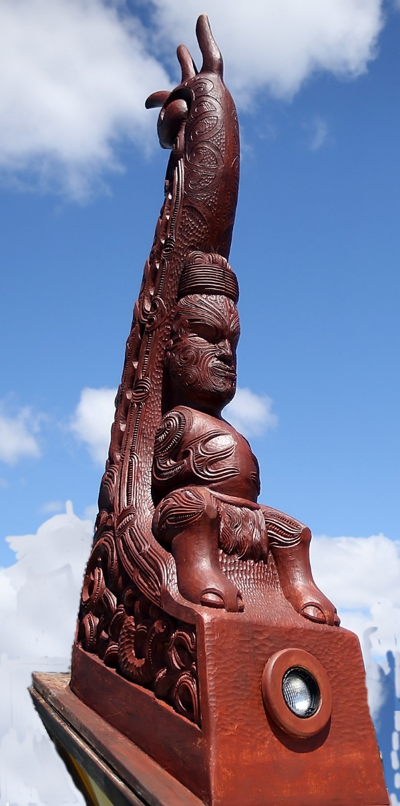

This Competent Crew/…. Task Book belongs to: Attach Photo Here

Family Name ___________________________________

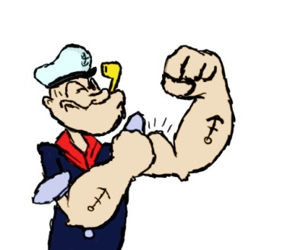

Given name ___________________________________

D.O.B. ___________________________________

Place of Birth ___________________________________

Home Address: ___________________________________

Home Phone: ___________________________________

Mobile ___________________________________

Email ___________________________________

This book is a record of your work. While replaceable, should it be lost any completed and signed off Task Book verifications would also be lost. Therefore, it is important that you get your NZMM assessor to sight your Task Book at regular intervals so your achievements can be recorded against your name. You may even consider photocopying each Task Book page as they are completed and keeping them in a separate file, and/or handing them on to your assessor.

By signing the declaration below I give permission for this document to be photocopied and shared with others, for the purpose of moderation, and for my personal details and academic results to be distributed to the relevant bodies for their information and recording (i.e.: NZO.A, ITO, Employer, MNZ etc.).

I understand that should I wish to make an appeal against a decision taken by my assessor, or regarding the assessment procedure, I can contact the Sailing Manager of NZMM for further details.

Candidate Declaration:

I hereby certify that all the work included in this Task Book is my own original work. I have not copied any part of it or have allowed or will allow any other student to copy any part of the assessment tasks.

Signed: __________________________________

Date: _____________

Contents

Introduction 4

The Task Book 4

Using the Task Book 4

Verifying the Tasks 4

Verification Table 5

Note to those Verifying Tasks 5

Task 1 Vessel Parts 5

Task 2 Vessel Familiarisation 7

Task 3 Spars and Standing Rigging 8

Task 4 Running Rigging 9

Task 5 Sails Identification 9

Task 6 Sails Parts 10

Task 7 Sails Handling 11

Task 8 Sail Commands 11

Task 9 Sail Trimming Commands 12

Task 10 Rope Work 13

Task 11 Berthing Terms 14

Task 12 My Ships Anchor 15

Task 13 Undertake Helmsman’s Duties 15

Task 14 Act as Lookout 17

Task 15 Health and Safety 18

Task 16 Personal Protective Equipment 20

Task 17 First Aid Equipment 21

Task 18 Emergency Signals 22

Task 19 Location of MOB Equipment 23

Task 20 Man Overboard Procedure 24

Task 21 Portable Extinguishers On My Ship 25

Task 22 Abandon Ship Equipment 26

# Introduction

The Competent Crew Task Book is designed as a stepping stone on the pathway to becoming a Kaumoana/Deckhand on Aotearoa One. Once completed it shows you have the basic skills and safety awareness required for sailing the Waka.

## The Task Book

Much of the knowledge and skills required by a Competent Crew will be gained on-job whilst serving on-board a vessel. The Task Book is designed as a guide to ensure you acquire the required skills and knowledge at the right level, and also to provide a record of your progress. Keep your Task Book handy so that you can take advantage of training opportunities as they arise, and keep it safe, it is your only record of the progress you have achieved.

The accompanying Text Book and Crew Manual contains some background information on each task to assist you acquiring the necessary knowledge. Using this information you will be able to complete some of the tasks yourself. Other tasks will require you to seek the assistance and guidance of more experienced crew or the master. All tasks will require verification by the master or other suitably qualified person to confirm that you have completed the task to the required standard.

## Using the Task Book

You can complete the sections and tasks within them in any order you wish, taking advantage of training opportunities as they arise. However it is a good idea to start by reading right through the Task Book so that you are familiar with all the tasks that need to be achieved. Once you have done this it is recommended that you devise a plan with your Instructor/supervisor to ensure all tasks are covered.

## Verifying the Tasks

All the tasks detailed in the Task Book must be verified by your skipper, supervisor or trainer once you have completed the task. It is most important that you get each task verified as you do it. The verification will indicate that you have completed the task yourself to the verifier’s satisfaction and in accordance with company policies and procedures.

## Verification Table

|  |  |  |  |
| --- | --- | --- | --- |
| **Verification Table** | | | |
| **Name** | **Position on-Board** | **Qualification** | **Signature** |
|  |  |  |  |
|  |  |  |  |
|  |  |  |  |
|  |  |  |  |
|  |  |  |  |
|  |  |  |  |
|  |  |  |  |
|  |  |  |  |

### Note to those Verifying Tasks

In verifying and signing off the tasks in this Task Book you are confirming that the trainee has completed the task themselves, has completed the task to your satisfaction, has followed company policies and procedures where appropriate and is competent to repeat the task.

Please do not sign off the task unless you are satisfied with the trainee’s performance of it.

If you accept sub-standard performance you will get the crew you deserve!

Verification of the task is indicated by completion of the signature block associated with each task. As some tasks are made up of a number of elements that may be verified by different members of the crew they may be individually verified by initialling the column adjacent to the task clement. Any member of the crew involved in the verification of tasks must fill in their details in the verification table above.

## Task 1 Vessel Parts

Using the check list below correctly identify the principal parts, operational areas and equipment found on your vessel to your skipper/supervisor. In the spare spaces list any additional principal parts or equipment on your vessel.

|  |  |  |  |
| --- | --- | --- | --- |
| Part | Correctly Identified | Part | Correctly Identified |
| Bow |  | Hatches |  |
| Stern |  | Accommodation |  |
| Port side |  | Galley |  |
| Starboard side |  | Holds |  |
| Hulls |  | Engine room |  |
| Centreline |  | Collision bulkhead |  |
| Amidships |  | Anchors |  |
| Forward |  | Capstan |  |
| Aft |  | Bollards |  |
| Bilge |  | Cleat |  |
| Main deck |  | Fairlead |  |
| Freeing ports |  |  |  |

Verified by ……………………………………………………………..

Signed …………………………………………….

Date ………………………………………………………………………………………

## Task 2 Vessel Familiarisation

|  |  |
| --- | --- |
| TASK | |
| LOCATE THE FOLLOWING DOCUMENTS: | |
| Safe Ship Management Certificate |  |
| Safe Ship Management manual or MOSS manual |  |
| Chart portfolio |  |
| NZ204 Nautical Almanac |  |
| LOCATE THE FOLLOWING NAVIGATION EQUIPMENT (if fitted) | |
| LOCATE THE FOLLOWING SAFETY EQUIPMENT: |  |
| Fire  Fire-fighting appliances  fire detection system  fixed fire-fighting installation  fire blankets  fire extinguishers  fire pump(s)  hydrants and hoses  Emergency Fuel Shutoffs |  |
| Location of PPE |  |
| EMERGENCY PREPAREDNESS |  |
| Vessel hazards |  |
| First Aid Kit |  |
| Operation of Fire/emergency alarms |  |
| Incident reporting forms |  |

This is to certify that I __________________________________ conducted this safety induction procedure on _____/_____/ _______ for ________________________________

Signed: _________________________________

## Task 3 Spars and Standing Rigging

|  |  |
| --- | --- |
| Task | |
| LOCATE THE FOLLOWING ON THE DIAGRAm | |
| Item | Number on Diagram |
| Main mast –Tiratū Matua |  |
| Main Boom –Tītoko |  |
| Mizzen mast – Tiratū Tokotū |  |
| Mizzen Boom – Tītoko |  |
| Stays - Waewae |  |

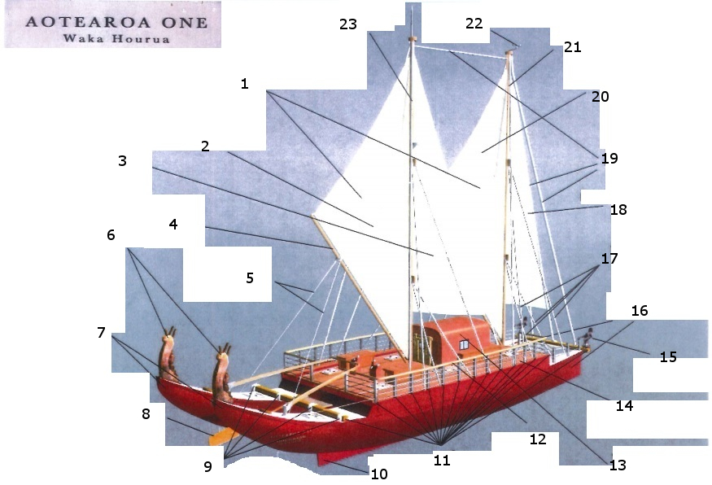

Verified by ……………………………………………………………..

Signed …………………………………………….

Date ………………………………………………………………………………………

## Task 4 Running Rigging

|  |  |
| --- | --- |
| Task | |
| LOCATE THE FOLLOWING ON THE DIAGRAM | |
| Item | Number on Diagram |
| Sheet lines – Taura Waha |  |
| Tricing lines – Taura Kutikuti |  |
| Halyards – Taura Tiratū |  |
| Outhaul – Taura Tītoko |  |

Verified by ……………………………………………………………..Signed …………………………………………….

Date ………………………………………………………………………………………

## Task 5 Sails Identification

|  |  |
| --- | --- |
| TASK – Sail Identification  DETAILS | |
| LOCATE THE FOLLOWING ON THE DIAGRAMS | |
| SAIL | A1 |
| Main –RāMatua |  |
| Mizzen – Rā Tauaki |  |
| Jib – Rā Ngonohau |  |
| Mizzen Staysail – Rā Ngongohau (Muri) |  |

Verified by ……………………………………………………………..

Signed …………………………………………….

Date ………………………………………………………………………………………

## Task 6 Sails Parts

|  |  |  |
| --- | --- | --- |
| TASK – Sail Parts  DETAILS | | |
| LOCATE THE FOLLOWING ON THE DIAGRAMS | | |
|  | Jib | Main/Mizzen |
| Luff |  |  |
| Head |  |  |
| Clew |  |  |
| Leach |  |  |
| Tack |  |  |
| Foot |  |  |
| Tack Pennant |  |  |

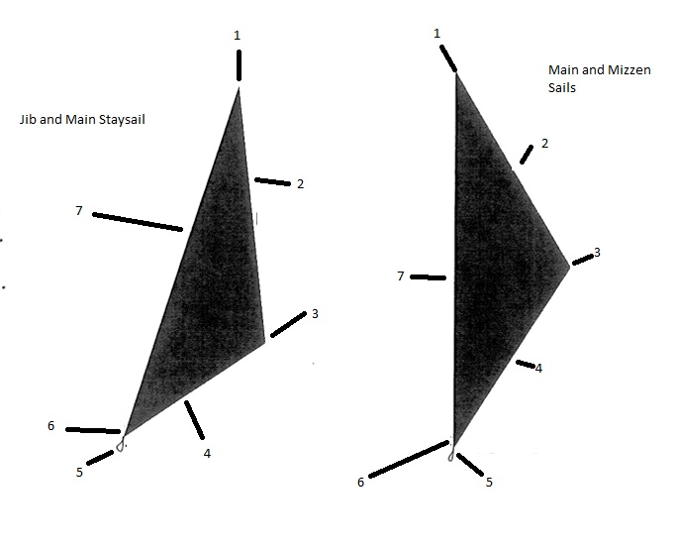

Verified by ……………………………………………………………..

Signed …………………………………………….

Date ………………………………………………………………………………………

## Task 7 Sails Handling

|  |  |  |  |  |
| --- | --- | --- | --- | --- |
| TASK – Sail Handling  DETAILS | | | | |
| Activity | Task Completed 3 times | | | Verified By |
| Date | Date | Date |
| Bend on |  |  |  |  |
| Set Jib |  |  |  |  |
| Douse Jib |  |  |  |  |
| Stow Jib |  |  |  |  |
| Bend on Main or Mizzen |  |  |  |  |
| Set Main or Mizzen |  |  |  |  |
| Reef Main or Mizzen |  |  |  |  |
| Douse Main or Mizzen |  |  |  |  |

Verified by ……………………………………………………………..

Signed …………………………………………….

Date ………………………………………………………………………………………

## Task 8 Sail Commands

|  |  |  |
| --- | --- | --- |
| TASK – Enter the Sail Commands from the Crew Manual  DETAILS | | |
| Basic Sail Command | English | Te Reo |
| 1 |  |  |
| 2 |  |  |
| 3 |  |  |
| 4 |  |  |
| 5 |  |  |
| 6 |  |  |
| 7 |  |  |
| 8 |  |  |
| 9 |  |  |
| 10 |  |  |
| 11 |  |  |
| 12 |  |  |

Verified by ……………………………………………………………..

Signed …………………………………………….

Date ………………………………………………………………………………………

## Task 9 Sail Trimming Commands

|  |  |  |
| --- | --- | --- |
| TASK – Enter the Sail Trimming Commands from the Crew Manual  DETAILS | | |
| Basic Sail Command | English | Te Reo |
| 1 |  |  |
| 2 |  |  |
| 3 |  |  |
| 4 |  |  |
| 5 |  |  |
| 6 |  |  |

Verified by ……………………………………………………………..

Signed …………………………………………….

Date ………………………………………………………………………………………

## Task 10 Rope Work

|  |  |  |  |
| --- | --- | --- | --- |
| DEMONSTRATE | USE/INTENDED PURPOSE | COMPLETED | Verified by |
| Reef knot |  |  |  |
| Clove hitch |  |  |  |
| Single & double  sheet bend |  |  |  |
| Round turn & two half hitches |  |  |  |
| Bowline |  |  |  |
| Figure of eight |  |  |  |
| Stopper Knot |  |  |  |
| Rolling hitch |  |  |  |
| Anchor bend |  |  |  |
| Bowline on the bight |  |  |  |
| Correct coiling and flaking of a rope |  |  |  |
| Sweating and Tailing |  |  |  |
| Flaking |  |  |  |
| Coil Down |  |  |  |
| Coil Hitch |  |  |  |
| Coil and throw a heaving line |  |  |  |

Verified by ……………………………………………………………..

Signed …………………………………………….

Date ………………………………………………………………………………………

## Task 11 Berthing Terms

|  |  |  |
| --- | --- | --- |
| TERM | MEANING | Verified By |
| Spring on |  |  |
| Stern On |  |  |
| Bow Line On |  |  |
| Spring Clear |  |  |
| Bow Clear |  |  |
| Stern Clear |  |  |

Verified by ……………………………………………………………..

Signed …………………………………………….

Date ………………………………………………………………………………………

## Task 12 My Ships Anchor

|  |  |  |
| --- | --- | --- |
| MY SHIPS ANCHOR GEAR | |  |
| Cable deck hazards |  |  |
| Protective equipment  used (personal) |  |  |
| Locate Anchor ball …. |  |  |

Verified by ……………………………………………………………..

Signed …………………………………………….

Date ………………………………………………………………………………………

## Task 13 Undertake Helmsman’s Duties

On at least six occasions in differing sea conditions steer the ship by hand.

|  |  |  |  |
| --- | --- | --- | --- |
| UNDERTAKE HELMSMAN’S DUTIES | | | Verified by |
| Date | Sea conditions | Remarks (e.g. passage, pilotage) |  |
|  |  |  |  |
|  |  |  |  |
|  |  |  |  |
|  |  |  |  |
|  |  |  |  |
|  |  |  |  |
| List Helm Commands | | | |
| Command | English | Te Reo |  |
| 1 |  |  |  |
| 2 |  |  |  |
| 3 |  |  |  |
| 4 |  |  |  |
| 5 |  |  |  |
| 6 |  |  |  |
| 7 |  |  |  |
| 8 |  |  |  |
| 9 |  |  |  |
| Record the orders and helmsman’s responses/ reports used on your ship to alter course from a course of 290 to 345 | |  |  |
| What report would you make to the skipper if the ship does not respond to the helm you have applied? | |  |  |
| How do you stop the ship in an emergency | |  |  |
| Describe how you would look after a magnetic compass and the causes of deviation | |  |  |

Verified by ……………………………………………………………..

Signed …………………………………………….

Date ………………………………………………………………………………………

## Task 14 Act as Lookout

|  |  |  |  |  |
| --- | --- | --- | --- | --- |
| ACTIVITY | DATE OCCASION | DATE OCCASION | REMARKS | Verified by |
| Act as lookout |  |  |  |  |
| Report contacts correctly |  |  | Describe reporting method |  |
| Hand over lookout duty correctly |  |  | List hand over points |  |
| Determine if risk of collision exists with another vessel |  |  | Explain how risk of collusion Is determined |  |

Verified by ……………………………………………………………..

Signed …………………………………………….

Date ………………………………………………………………………………………

## Task 15 Health and Safety

|  |  |  |
| --- | --- | --- |
| HEALTH AND SAFETY | | Verified by |
| Identify & describe how employers should ensure your  safety under the H&S Employment Act |  |  |
| Identify & describe your responsibilities under the H&S Employment Act |  |  |
| Describe in your own words the purpose of the MTOP and Vessel Manual |  |  |
| Which Parts of the Vessel Manual particularly apply to your responsibilities as a deckhand? |  |  |
| Where is your vessel’s MTOP located? |  |  |

|  |  |  |  |
| --- | --- | --- | --- |
| List the information on your Survey Certificate | Vessel Name |  |  |
| Homeport |  |  |
| MNZ Number |  |  |
| Length |  |  |
| Type of Ship |  |  |
| Valid Until |  |  |
| Date of Issue |  |  |
| Area of Operation |  |  |
| No: of crew |  |  |
| No: of passengers |  |  |

Verified by ……………………………………………………………..

Signed …………………………………………….

Date ………………………………………………………………………………………

## Task 16 Personal Protective Equipment

|  |  |  |
| --- | --- | --- |
| PERSONAL PROTIECTIVE EQUIPMENT | | Verified by |
| List the PPE you would use in the tasks listed below | |  |
| Berthing/un- berthing |  |  |
| Anchor work |  |  |
| Cleaning |  |  |
| General operation |  |  |

Verified by ……………………………………………………………..

Signed …………………………………………….

Date ………………………………………………………………………………………

## Task 17 First Aid Equipment

In the event of injury to a passenger or crew it is important to know where to find the appropriate first aid equipment. Check where first aid equipment is stowed in your vessel and complete the table below.

|  |  |  |  |
| --- | --- | --- | --- |
| Equipment | Location/s | Remarks | Verified by |
| First aid kit |  |  |  |
| Defibrillator |  |  |  |
| Other |  |  |  |

Verified by ……………………………………………………………..

Signed …………………………………………….

Date ………………………………………………………………………………………

## Task 18 Emergency Signals

Complete the table below for the emergency signals used on your vessel.

|  |  |  |  |  |
| --- | --- | --- | --- | --- |
| SIGNAL | THE SIGNAL IS | SIGNALLING DEVICE | YOUR RESPONSE | Verified by |
| General Emergency |  |  |  |  |
| Abandon Ship |  |  |  |  |
| MOB |  |  |  |  |
| Other |  |  |  |  |

Verified by ……………………………………………………………..

Signed …………………………………………….

Date ………………………………………………………………………………………

## Task 19 Location of MOB Equipment

|  |  |  |  |
| --- | --- | --- | --- |
| LOCATION OF MOB EQUIPMENT | | | Verified by |
| Type of  Equipment | Location | Remarks |  |
| Lifebuoys |  |  |  |
| Throw lines |  |  |  |
| Dan buoy |  |  |  |
| Buoyancy apparatus |  |  |  |

Verified by ……………………………………………………………..

Signed …………………………………………….

Date ………………………………………………………………………………………

## Task 20 Man Overboard Procedure

Study your MTOP and then in the table below describe your duties during a man overboard.

|  |  |  |
| --- | --- | --- |
| MAN OVERBOARD PROCEDURE | | Verified by |
| My duties during a MOB are |  |  |
| Take part in an MOB drills on your vessel: | Drill – Date …………………………………………… |  |

Verified by ……………………………………………………………..

Signed …………………………………………….

Date ………………………………………………………………………………………

## Task 21 Portable Extinguishers On My Ship

Identify all the extinguishers on your ship and complete the table below.

|  |  |  |  |  |  |
| --- | --- | --- | --- | --- | --- |
| PORTABLE EXTINGUISHERS ON MY SHIP | | | | | Verified by |
| Type | Size | Location | Suitable for Class? Fires | Time to discharge |  |
|  |  |  |  |  |  |
|  |  |  |  |  |  |
|  |  |  |  |  |  |
|  |  |  |  |  |  |
|  |  |  |  |  |  |
|  |  |  |  |  |  |

Verified by ……………………………………………………………..

Signed …………………………………………….

Date ………………………………………………………………………………………

## Task 22 Abandon Ship Equipment

Identify all the equipment on-board used for abandoning ship and complete the table below

|  |  |  |  |
| --- | --- | --- | --- |
| ABANDON SHIP EQUIPMENT | | | Verified by |
| Equipment | Location | Size/How Maintained/Deployed |  |
| Lifejackets |  |  |  |
| Life rafts |  |  |  |
| Buoyancy Apparatus |  |  |  |

Verified by ……………………………………………………………..

Signed …………………………………………….

Date ………………………………………………………………………………………